 | 12.1.70 Editors - Geometry Nodes Editor - Header - Add Menu - Geometry Nodegroups - Instances
Table of content
Detailed table of content 1
Add menu - Geometry nodes - Instances 1
Instance on Elements 2
Randomize Transforms 2

Detailed table of content
Detailed table of content
Detailed table of content 1
Add menu - Geometry nodes - Instances 1
Instance on Elements 2
Randomize Transforms 2

Add menu - Geometry nodes - Instances

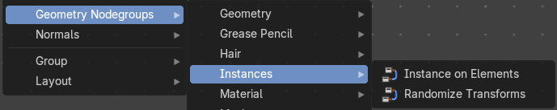
The nodes in this submenu are node groups. They use the regular single nodes under the hood.
It is virtually impossible to document these nodes in detail. So we will just list them.
When you double click the header, then you will enter the first level of the group. When you then press tab, or click again at the header, then you will reach the single nodes.




To leave the group you can use the breadcrumb up left in the header. These breadcrumbs are clickable. Or the Parent Node Tree button up right in the header.

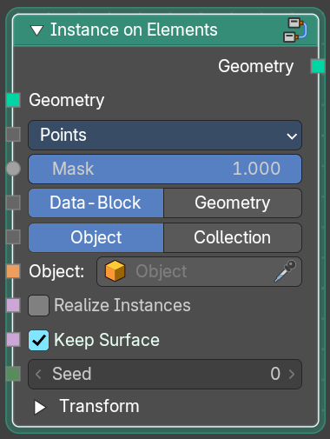
Instance on Elements
Create copies of referenced geometry on geometry elements.

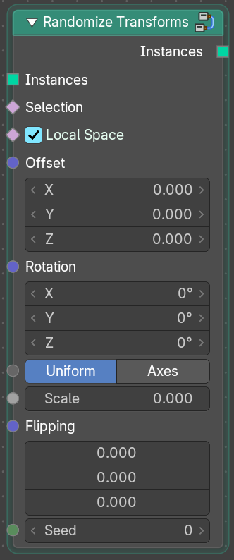
Randomize Transforms
Randomize the transform of instances.

